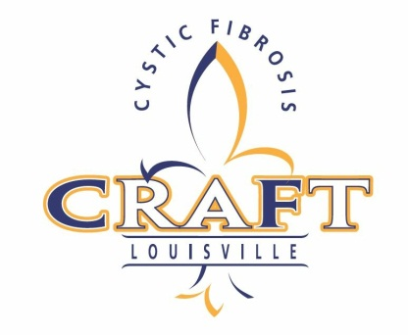
•CRAFT•
OCTOBER 10, 2015
SPONSORSHIP COMMITMENT FORM

[ ] PRESENTING SPONSOR  $5,000 (tax deductibility: $4,600) | [ ] ALE SPONSOR  $1,000 (tax deductibility: $880)
[ ] LAGER SPONSOR  $2,500 (tax deductibility: $2,300) | [ ] PILSNER SPONSOR  $500 (tax deductibility: $460)
[ ] OTHER _______________

CONTACT INFORMATION

_____________________________________________________________________
PERSON/ORGANIZATION (as it should appear in printed material)

_____________________________________________________________________
ADDRESS

_____________________________________________________________________
CITY STATE ZIP

_____________________________________________________________________
TELEPHONE EMAIL

METHOD OF PAYMENT
[ ] Enclosed is my check payable to Cure CF, Inc, 1616 Forest Hill Dr. Louisville, KY 40205
[ ] Please charge my credit card: [ ] MC [ ] VISA [ ] Discover [ ] AMEX

ACCOUNT #: __________________________________________ EXP/CVV: _______

SIGNATURE: __________________________________________________________
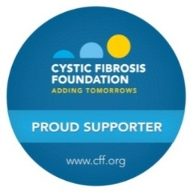

Important note on attendance for people with CF and their families:
The health and well-being of people with Cystic Fibrosis is our top priority. Medical evidence shows that certain bacteria can be passed between individuals who have CF and can lead to worse symptoms and speed decline in lung function. To limit the serious risk of cross-infection between people with CF, at any outdoor event, people with CF should maintain a distance of at least 6 feet from each other. For more information, please call us at 502-609-2855.

